Math 5
Project Write-Up
Nick Brown

Music Composition
Nick Brown and Will Raymer

When Will and I set out to begin writing our piece for Math 5, we weren’t sure of the best way to start composing. So many ideas or concepts have been the basis of compositions in the past, that there’s no clear point to begin at. Literary works of all kinds have been used to generate pieces, composers have written pieces based upon imagined scenes or heroic triumphs, mathematical formulae have given rise to pieces, and some composers have even used complete stochastic chance to allow an individual to compose a piece differently every time. However, the spectral music of Gerard Grisey (and others, including Tristan Murail) uses an entirely new basis for composition—that of the actual acoustic material of sound. Especially given the focus of this class, we thought that basing at least some aspects of our piece on that spectral music would be a good idea. A quote from the Grove Music Dictionary article on spectral music sums up the technique well, saying “Partiels” (a piece by Grisey) is a work that “uses the acoustic properties of sound itself (or sound spectra) as the basis of its compositional material.” Essentially, these composers of spectral music work closely with sound spectrum derived from Fourier analysis of a sound, and compose a piece based upon what they can see from the spectral analysis.
In “Partiels”, Grisey begins with an attempt at re-synthesizing the spectrum produced by a low E2 played by the trombone. However, rather than using a trombone or a computer to create that tone, he uses a number of other instruments, playing at different volumes on each of the notes of the harmonic series that was excited by the original E2. As the piece progresses, Grisey explores the higher harmonics of the trombone more and more thoroughly. Due to the nature of the harmonic series, the piece becomes more dissonant and grating, as the higher harmonics grow stronger—the first few partials of any tone are very consonant (root, octave, fifth, octave, major third, fifth), while the upper partials become microtonal and dissonant with both each other and the root note. However, these upper partials are not usually strongly perceived—it is only in this type of music where their dissonant relationship to the perceived fundamental pitch is brought out.
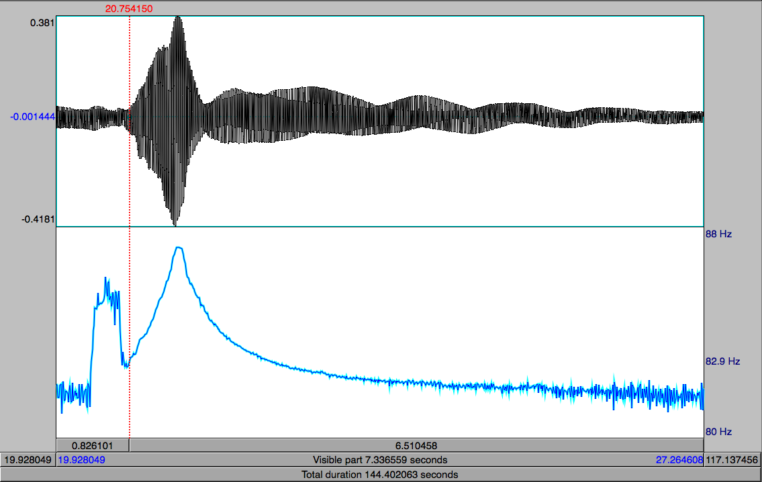
This focus on spectral analysis was one of the guiding principles of our composition. We began by playing around with our electric guitar and violin simply searching for an interesting sound to analyze and begin working with. We discovered this sound when we tried bowing the low E string of the guitar with a violin bow (interesting, also an E2, much like Grisey’s trombone). What we discovered was interesting—by bowing the string, the string was pulled far enough out of its normal modes that it warped sharp by a little more than a semitone up to an F2, before decaying back slowly towards its normal pitch. We decided to analyze this sound in Praat to get a better idea of exactly how the pitch was varying, and found the above figure as a result. As can be seen, the pitch varied from 82.7 Hz, up to 87.2 Hz and back down to 81.6 Hz. Also interesting is the amount of resonance we heard from harmonics of the upper strings of the guitar when we bowed the low E2—far more than typically experienced when the E string is excited solely by plucking or strumming.
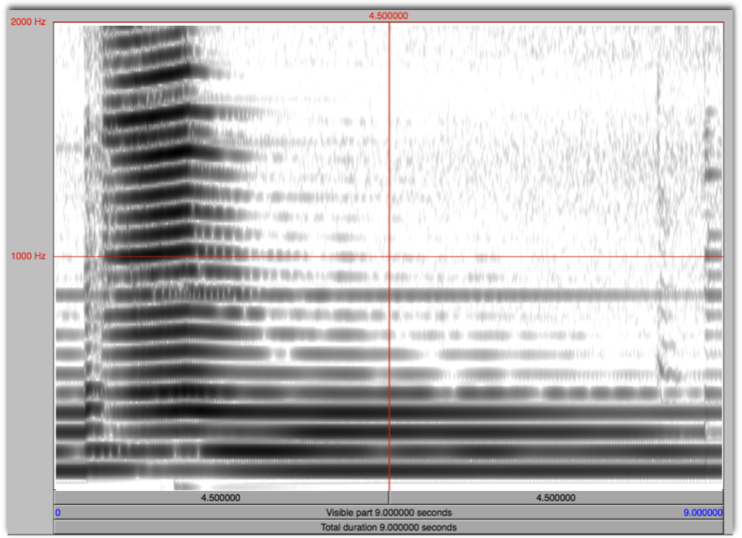
To further explore this idea, we decided to retune the upper strings of the guitar in two different manners while continuing to bow the low E string, and then observe the effects of this retuning on the harmonics we were hearing. First, we tuned the upper strings of the guitar to notes found in the E harmonic series (E-B-E-G#-B-E). In the spectrogram found above, we examined the results. Essentially, as predicted, the notes in the E harmonic series sustained particularly strongly. As the pitch bent upwards, the ringing harmonics of the upper strings remained constant. The next test that we did in generating material for our composition was tuning the upper strings to notes in the F harmonic series (E-A-F-A-C-F). In this case, the spectrogram reveals a more interesting phenomenon. As we can see from the spectrogram below, a number of upper harmonics are not excited until the pitch of the warping E string bends up to an F and one of the upper partials’ frequencies meets the frequency of the re-tuned upper guitar strings.
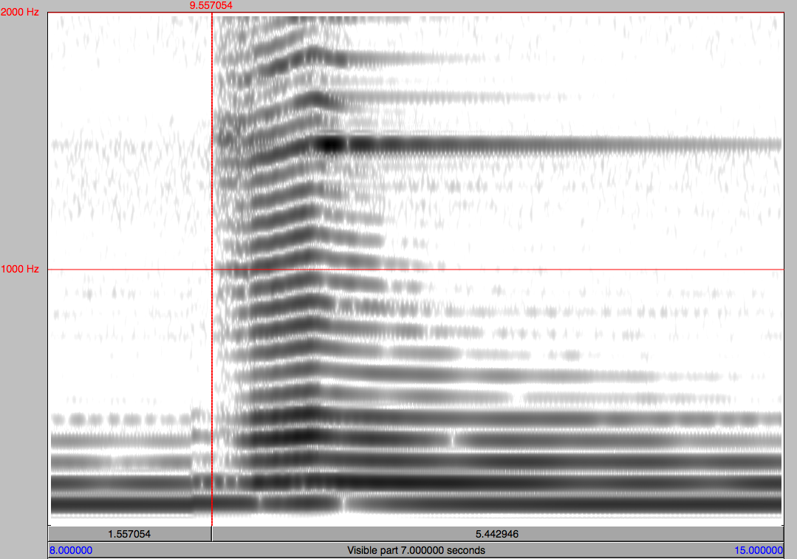
In addition to these interesting sounds, Will and I worked with a number of other ideas to generate a large bank of sounds for use in our composition, including pitch shifting sounds we had recorded, retuning the violin and striking it in a variety of ways to excite sound, and playing guitar harmonics in a variety of tunings. Altogether, we generated roughly 23 minutes of recorded material. However, even with a solid repertoire of interesting sounds and techniques, we were somewhat at a loss until Professor Michael Casey, with whom we also have been working on some compositions, suggested we implement his program Sound Spotter.
Sound Spotter is a very interesting program that can take a large batch of sound and process it into an interesting playback that is fully customizable by the user. It achieves this by cutting any sound file that is loaded into many short chunks, and then playing them back with relation to a select set of parameters. As primary inputs, the program lets you choose the window size, which determines the length of the segments Sound Spotter will chop the batch of sound into, and distance, which determines how similar or dissimilar each subsequent chunk will be to the previous chunk. Essentially, with a distance of zero, Sound Spotter will play the same (or very similar) brief moment in time over and over, and with a distance value of 4 (the maximum), each subsequent sound will be as far different from the previous one as possible. Other parameters further enable you to customize the sound—queue allows the user to dictate how much time elapses between the computer being able to repeat sounds, feedback determines whether the application responds to outside noise picked up by the microphone or responds to the internal sound being played by Sound Spotter itself, and LoBasis/NumBasis determines whether the similarity between sound sections is determined by timbre or by pitch.
The way that Will and I chose to use Sound Spotter was not simply to play back our 23 minutes of material in one stream, but rather to set up two computers with the same reference .wav file, that were listening to each other and playing back the material according to different parameters. In the 5 minute long piece that we ended up creating, one of the computers begins with Sound Spotter’s distance turned to 0, and the other with the distance at the maximum of 4. Over the course of the piece, these values were slowly changed, revealing a gradual process that yielded some very satisfying results. In addition to the slow crossing of distance values, the window size for the two computers were set at 20 and 21, thus producing a rhythmic phasing effect, wherein the two computers play a sound in sync only once every 21 cycles. In between, the chunks move slowly more and more out of time, producing an interesting polyrhythmic effect between the two parts. Between this rhythmic phasing, the character of the sounds we created and the modulation of the distance values, I think that we came across a pretty interesting conceptual piece.

References:
Anderson, Julian. "Spectral music." Grove Music Online. Oxford Music Online. http://www.oxfordmusiconline.com/subscriber/article/grove/music/50982

Feldman, Morton. “Piano, Violin, Viola, Cello.”

Reich, Steve. “Music as a Gradual Process.” http://www.columbia.edu/ccnmtl/draft/ben/feld/mod1/readings/reich.html

Reich, Steve. “Violin Phase,” and “Piano Phase.”

Young, La Monte. “Excerpt "31 | 69 c. 12:17:33-12:25:33 PM NYC" & "31 | 69 C. 12:17:33-12:24:33 PM NYC"

