Patrick Gould
Professor Alex Barnett
Math 53
Epidemiology and Chaos

Introduction

Epidemiologists use mathematical models to understand previous outbreaks of diseases and to better understand the dynamics of how infections spread through populations. Many existing models closely approximate historical disease patterns. This project investigates the chaotic behavior of one of the most popular models for the spread of disease, the SEIR model. The presence of chaos in the model has serious implications for the accuracy of predictions from the model, as miniscule changes in initial conditions could produce large effects in results.

The SEIR Model

The SEIR model divides the total population into four separate groups: susceptible, exposed, infective, and recovered. Susceptible people have not yet been exposed to the disease, while those in the exposed group have come in contact with the disease but are not yet ready to pass the disease on to others. Infectives can pass the disease on, and those in the recovered group can no longer catch the infection; it is assumed that the disease confers immunity after recovery. The following equations govern the system:

In the system, μ represents both the birth and death rate (the model assumes a constant total population), α is the rate at which exposed people become infective, and γ is the rate at which infectives recover. β(t) is the contact rate at which susceptibles come into contact with the infectives. This rate varies sinusoidally to represent changes in infectivity according to the season. This sinusoidal contact rate introduces chaos and unpredictability into the model (Wu, Chen, & Yuan, 2008).

Analysis of the SEIR Model

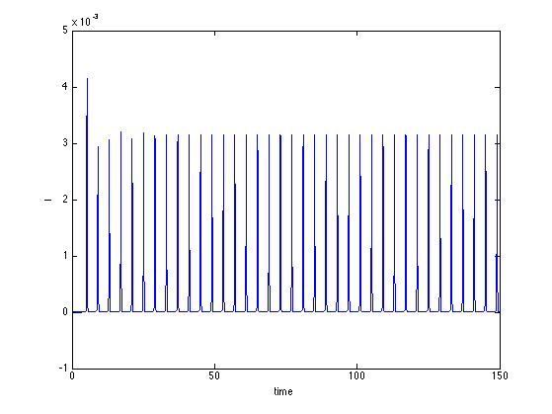
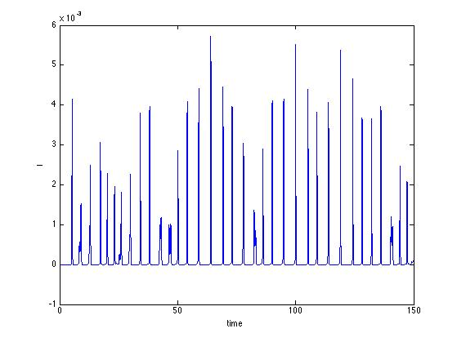
I used Matlab to analyze this SEIR model, using parameter values taken from previous studies of the system (μ = 0.02(year)⁻¹, α = 1/0.0279(year)⁻¹, γ = 1/0.01(year)⁻¹, β₀ = 1575.0(year)⁻¹ (Wu, Chen, & Yuan, 2008). I assumed a constant total population of 1, so each variable simply represents a fraction of the total population. Also, because population always sums to 1, I did not include the equation for R in the model, as the value of R can always be produced from the other three values. The parameter β₁, which represents the amplitude of the sinusoidal function for infectivity, will be varied, as large values of this parameter produce chaotic dynamics (Wu, Chen, & Yuan, 2008). Below are two time series with β₁ = 0.15 (top) and 0.28 (bottom). In both graphs, the number of infectives, I, is plotted on the y axis. It is clear that at β₁ = 0.28, the dynamics of the system are much more complicated and chaotic.

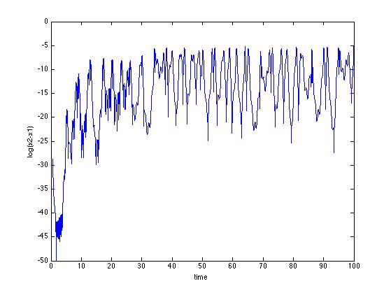
To investigate the properties of the system with β₁ = 0.28, I studied sensitive dependence and Lyapunov exponents. Below is a chart plotting the natural log of the difference in the number of infectives between two different trajectories that differed by 10e-4 in initial conditions in each variable (S₀ = 0.02, E₀ = 0.003, I₀ = 0.002). Even though the plot does exhibit a vaguely upward trend between time 0 and 40 followed by a plateau, the graph is wildly variable. These wild swings arise from the nature of the SEIR model, which results in large outbreaks among periods of almost zero infectives. Therefore, differences in the two trajectories are virtually shrunk to zero during the troughs of the model (visible in the graph below of both trajectories on one plot). However, I did measure the slope of the above graph between time 0 and 35, which (crudely) estimated the leading Lyapunov exponent to be a barely positive value of 0.386.

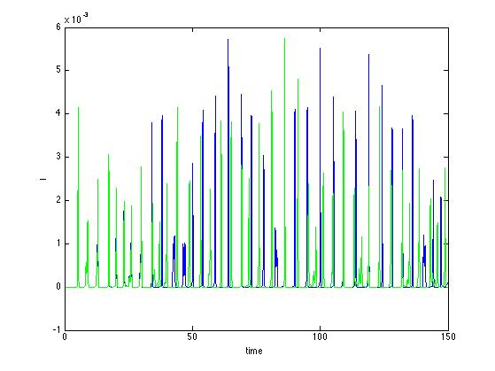

However, the above method for calculating Lyapunov exponents is not precise, so I also calculated Lyapunov exponents by using a time-one map of the flow to measure the repeated effects of the Jacobean on a unit sphere. I modified code given in class that calculated Lyapunov exponents for the Lorenz attractor to produce Lyapunov exponents for this SEIR system. This method produced two negative Lyapunov exponents and a positive one with value 0.2923, which suggests chaos. Surprisingly, the two different methods did produce similar Lyapunov exponents. Also, to estimate the effects of changing β₁ on the dynamics of the system, I calculated Lyapunov exponents for values of β₁ between 0.2 and 0.28, with a step value of 0.1. Below is a plot of the largest Lyapunov exponent for each value of β₁.
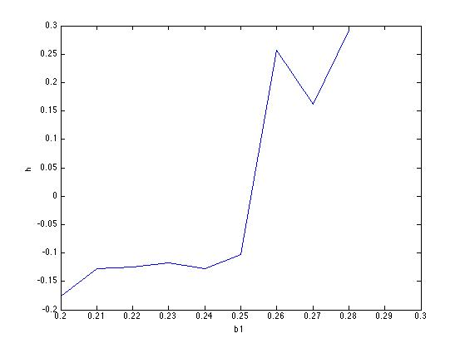
As the graph shows, it appears that the system becomes chaotic somewhere between β₁ = 0.25 and 0.26. This value is fairly consistent with values appearing in the literature, which stated that a β₁ value of 0.27 is necessary for chaos (Wu, Chen, & Yuan, 2008). Finally, below is a plot of the chaotic attractor for β₁ = 0.28 after 150 years.

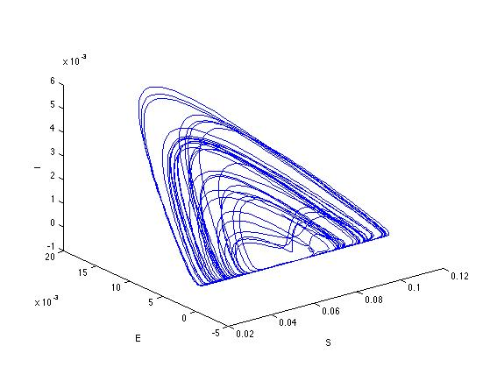

S, E, and I appear on the three axes as a fraction of total population. Although the attractor appears to exist in a plane, the graph does “bulge” in the middle and so exists on a 2-d surface. The attractor demonstrates how outbreaks work in the model: many repeated increases and decreases of E and I between periods of very low E and I.

Discussion

The described SEIR model has been shown to produce results very similar to real epidemics. For example, the figure below compares real measles data to data produced with the SEIR model. The two columns on the left contain data from outbreaks in New York and Baltimore, while the right column contains data from the SEIR model. The graphs from top to bottom are the attractor, the attractor viewed from above, and a Poincaré section. As the figure shows, the SEIR model is almost indistuingishable from real data (Schaffer, 1987, pg. 246).

However, even though the SEIR model does produce accurate results, the parameters necessary to achieve these results do not apply well to real world conditions. Specifically, the high β₁ values that produce chaos correspond to amplitudes that are thought to be too high to be possible in the real world (Bolker & Greenfell, 1993). Therefore, even though SEIR might be able to mimic real data, its unrealistic parameters make it relevancy doubtful. Furthermore, the model also produces very low values of infectives in its troughs. The graph below is a zoomed-in view of one of the troughs in the infective population. As the graph shows, during this time period, the fraction of the population that is infective is virtually zero. Therefore, only enormous populations (e.g. an unrealistic 10¹⁵ people) could possibly be represented by this model because the disease would quickly die out in any smaller population (Bolker and Greenfell, 1993).
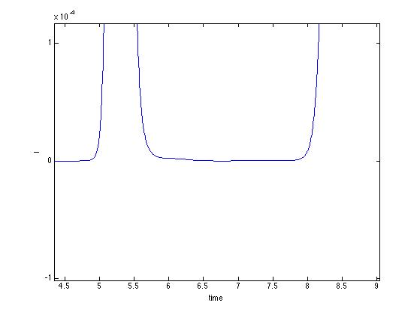

Due to these problems with the SEIR model, epidemiologists now assert that epidemics are more accurately described by a mix of deterministic and stochastic forces. Stochastic variations in populations and environments simply play a large role in determining when an outbreak of a disease will occur (Grenfell, 1992). Therefore, even though the SEIR model does exhibit chaotic behavior of a deterministic behavior, it is unfortunately not the best model to describe the seemingly chaotic nature of epidemics.

Sources

Al-Showaikh, F. & Twizell, E. (2004). One-dimensional Measles Dynamics. Applied Mathematics and Computation, 152, 169-194.

Billings, L. & Schwartz, I. (2002). Exciting Chaos with Noise: Unexpected Dynamics in Epidemic Outbreaks. Mathematical Biology, 44, 31-48.

Bolker, B. (1993). Chaos and Complexity in Measles Models: A Comparative Numerical Study. Journal of Mathematics Applies in Medicine and Biology, 10, 83-95.

Bolker, M. & Grenfell, B. (1993). Chaos and Biological Complexity in Measles Dynamics. Proceedings: Biological Sciences, 251, 75-81.

Grenfell, B. (1992). Chance and Chaos in Measles Dynamics. Journal of the Royal Statistical Society, 54(2), 383-398.

Murray, J.D. (1989) Mathematical Biology. New York: Springer-Verlag.

Schaffer, W. M. (1987). Chaos in Ecology and Epidemiology. In H. Degn, A. Holden, & L. Olsen (Eds.), Chaos in Biological Systems (233-248). New York: Plenum Press.

Sidorowich, J. (1992). Repellors Attract Attention. Nature, 355, 584-585.

Sumi, A., Ohtomo, N., Tanaka, Y., Sawamura, S., Olsen, L., & Kobayashi, N. (2003). Prediction Analysis for Measles Epidemics. Japan Journal of Applied Physics, 42, 7611-7620.

Wu, W., Chen, Z., & Yuan, Z. (2008). A Rigorous Verification of Horseshoe Chaos in a Seasonally Forced SEIR Epidemic Model. The 9th International Conference for Young Computer Scientists.

