Maggie Flanagan
Math 5
Fall 2011
Lassie Noir
For my final project, I decided to create a sound mystery using some of the sound analysis and synthesis techniques we learned this term. I have summarized my methods below, including some lovely trial and error pieces.
My project is an aural mystery called “Lassie Noir”. The story follows Lassie, an inner city pit bull, as she investigates the mysterious disappearance of a toddler in a fancy Chicago high rise apartment. Her first clue is the sound of a police car speeding through her neighborhood at a faster-than-normal speed
1. Doppler
In the first scene of our mystery, Lassie hears the sound of a siren of a police car whizz past her alleyway. She follows the sound.
The signal I started with had the primary frequencies 1382Hz and 1032Hz. I calculated the approaching and retreating Doppler signals for each of these frequencies, and then tried desperately to pitch the siren as it approaches and retreats from the observer. This is at 20.12 m/s, or 45mph.

Towards:
f(obs) = $\frac{1}{1-\frac{V}{c}}$
1382Hz 1468.9Hz
1032Hz 1096.7Hz
Away:
f(obs) = $\frac{1}{1+\frac{V}{c}}$
1382Hz 1304.8Hz
1032Hz 980Hz

This sound was particularly hard to simulate because Audacity shortens the wavelength to increase pitch, thus shortening the duration of the signal, which causes it to sound choppy. It’s a choppy sound, but I tried! Below is the Audacity screen shot for this sound file, including all atmospheric and theatrical sounds.
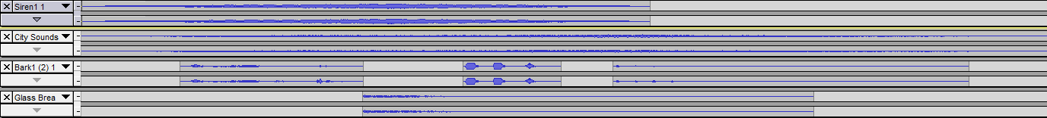

2. Down the Rabbit Hole
When Lassie gets to the scene of the accident she finds a hole in the floor of the high rise apartment building, through which the baby’s chassey seems to have fallen. Lassie barks down the hole, and receives an echo. I determined the depth of the hole to be 12 feet deep, or 3.6576 m.
t= 2L/c
The time difference ended up being 0.0215 seconds, so I applied the echo effect on Audacity to one of the barking sounds from Freesound, put in the time, and came up with the following sound file (with added sounds).
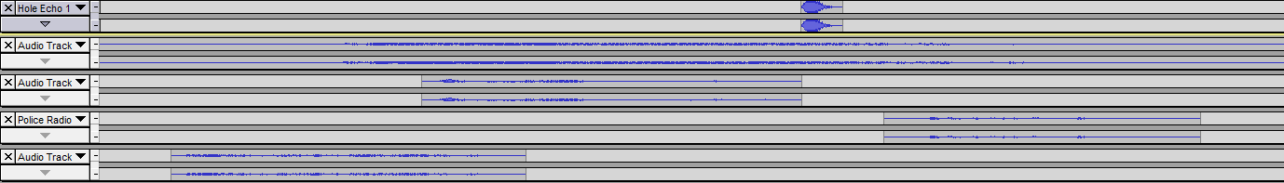
3. The Dark Passage
Upon jumping into the dark pit, Lassie finds herself in a pitch black space. She barks, and hears a flutter echo in response. She is in a tunnel 40m long and 2m wide. Lassie is standing in the center of the width.

Echos occur at:
T = 2L/c
= 0.01173 sec
Flutter echos:
S = D/T
= 3400Hz

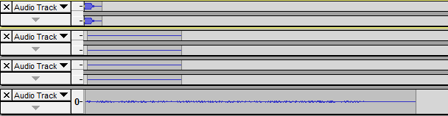
I combined a very low amplitude pure tone at 3400Hz and some white noise to simulate the buzz of a flutter echo, and placed it inside and after a bark. The rumble in the background is a little weaker than I intended, but it still seems to be present.

4. Reverb Storage Room
Lassie reaches the end of the tunnel and pushes her way past the broken door into a dimly lit room littered with bottles and shiny things. She accidently breaks a bottle in an attempt to get through the room, and the sound reverberates in the mostly empty room. I applied the reverberation time to the echo of the glass breaking in the first few seconds of this clip.
Room Measurements: 5m×5m×2.74m with one door, 2.13m×0.91m, open
Material: Wood (0.07 absorption)
Reverberation Time:
T60 = 0.161V/(Sa)
= 0.4798 seconds
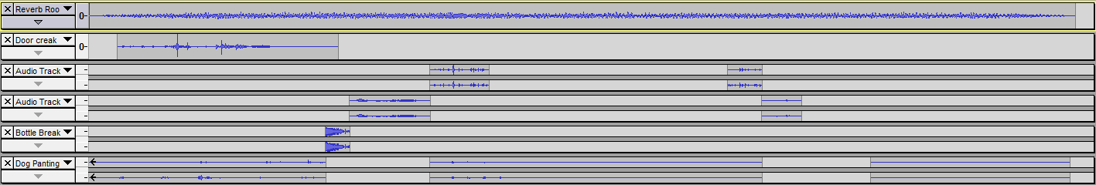

5. Incoming!
After making her way through the room of broken glass, Lassie finds the baby in its carriage in a large metal alcove. She tries to tug the carriage out, but can’t. There seems to be a whine coming from this alcove… and it’s getting higher and louder the longer Lassie stands there.
My calculations:
Dominant frequency of elevator hum: 120Hz
Doppler (towards):
f(obs) = $\frac{1}{1-\frac{V}{c}}$
120Hz 236Hz
I achieved this by periodically using the “Change Pitch” function on Audacity, applying it to the elevator buzz sound until I had reached the desired pitch, at which the elevator should have “passed” them, but actually just came crashing down on the baby carriage. It was tricky to get the timing right. I started with the elevator being on the 14th floor instead of the 28th, because that would have taken a whole minute. With 14 floors to go, the elevator took 32.8 seconds to descend, so some time is left at the beginning where the elevator is “paused” at the 14th floor. It then starts to move, and take 32.8 seconds to arrive at the bottom floor. This is possibly my favorite sound file in this project.
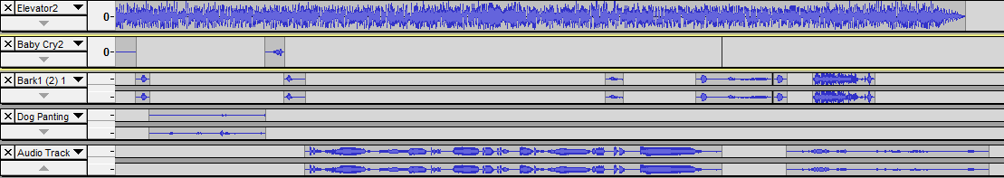

6. Barking up the wrong hole...
Lassie grabs the baby out of the chassey and manages to narrowly avoid the descending elevator. The chassey isn’t so lucky. Lassie, terrified, bolts, baby in tow, into a tunnel. She barks one way and another to find an exit in the darkness. One way yields another flutter echo, the other yields…nothing. The first and second barks have no echo, while the third and fourth have a flutter echo from a passage 15m deep and 1m wide.

Echos occur at:
T = 2L/c
= 0.0029 sec
Flutter echos:
S = D/T
= 5100Hz

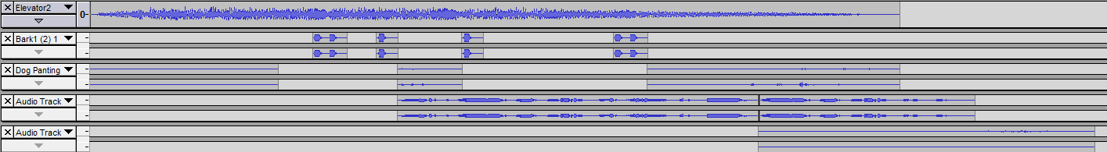

7. Putting it all together…
I put the story together to the tune of “Dark Coffee Meets Jazz Soul” from Gyakuten Meets Jazz Soul (Capcom, 2007). Some of the tracks ended up being quieter than others, so I manipulated the amplitude of the backtrack so that each action sequence could stand out on its own. The last step was the addition of narration over the tracks. The narration was read by Max Fagin (’11).
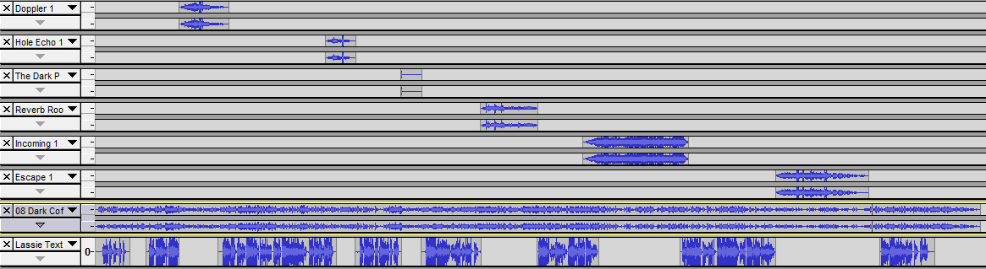
That was fun!

