CHAOS IN MULTI-TROPHIC FOOD WEBS

Benjamin Bier
Peter Hughes
Tayla Martin

Abstract
When biologically reasonable parameters are chosen, it is possible to find chaotic behavior in unilateral three and four-species food chains over sufficiently long time intervals. Similarly, open three-species cyclic models yield chaotic dynamics while closed cyclic models do not. Lyapunov Exponent calculations, three-dimensional phase plots, Poincare Maps, and a bifurcation diagram were our primary tools of analysis in finding these results. The presence of chaos in these biological system models suggests that chaotic dynamics are present in naturally occurring multi-trophic food webs and provides grounds for caution in the reliance on long-term predictive population models.

Introduction

Naturally occurring ecological systems consist of a wide number of species and are defined by a complex arrangement of interactions between these players. From a mathematical standpoint, it is difficult to appropriately model all of these complex interactions, but researchers are attempting to model food webs in simpler ways. Most past studies consider only two-species interactions due to the analytic simplicity of this model. Two-species interactions, however, are not commonly observed in nature and, thus, conclusions drawn from these models are incomplete. When studies do consider three or more species they do so by considering the interspecies relationships to be either pair wise or unilateral. In a three-species
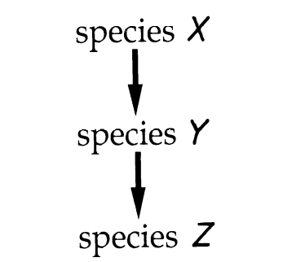
Figure 1: A standard, unilateral three-species food chain. Arrows go from prey to predators.

unilateral system as seen in Figure 1, species X is a producer which is consumed by primary consumer Y which is then preyed upon by secondary consumer Z. While the unilateral approach is not entirely complete either, it does capture features which a pair wise modeling could not such as how the population of a producer affects not only the population of the primary consumer but that of the secondary consumer as well.
For these reasons, we followed the work of Hastings and Powell closely to reproduce a three-species unilateral model. We then modified their model to analyze a unilateral, cyclic system through the inclusion of a detrital pool comprised of the dead organic matter from the primary and secondary consumers Y and Z which goes back into the system by providing nutrients to species X. This cyclic model was analyzed for both an open system – a system with energy input from the sun – and closed system – a system with no energy input. Lastly, we produced a model that analyzed the behavior of a four-species unilateral system through the addition of fourth species, W.

Three Tier Trophic Unilateral Modeling and Analysis

The equations used by Hastings and Powell closely follow the classic predator-prey Lotka Volterra model, which takes into account the carrying capacity of a species’ environment as well as the species’ exponential growth and predation against the species. The major distinction between the Hastings and Powell equations and the classic model is the incorporation of a Holling's type II saturation functional response of the form: 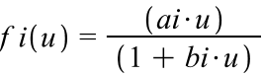 (Hastings and Powell, 1991). Here, i is representative of either 1 or 2 in accordance with which predator-prey relationship is being referenced, either that between X and Y or Y and Z. Variable a is a control on the rate of saturation and b is the prey population at which the predation rate per unit prey is half of the eventual saturation value (Hastings and Powell, 1991). The type II saturation functional response is formulated around the fact that, as the density of prey increases, the number of prey killed increases to a point but then levels off. This is due to a time limitation. It takes a certain amount of time for predators to track down, capture, and consume prey. Thus, at some point when the predator is spending all of its time feeding on the prey due to high density, there is no way to increase the number of prey consumed despite a continuing increase in prey density (Skalski and Gilliam, 2001). After being nondimensionalized, the equations are as follows:

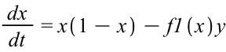
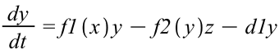
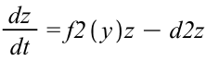

The equations listed below place a carrying capacity on species X but none on Y or Z since they are reliant directly and indirectly on the population of X. Variables d1 and d2 are the death rates of species Y and Z, respectively.
Now, we took the parameters used by Hastings and Powell seen in Figure 2 below to reproduce species versus time graphs and three-dimensional phase plots of the system. As you can see, it is a necessary condition

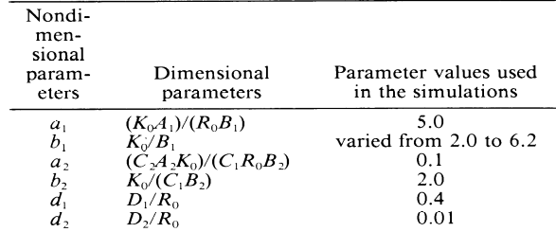

Figure 2: The above nondimensionalized and dimensionalized parameters were used in simulations of Hasting and Powell’s model. Notice b1 was the only parameter value changed to alter the model’s behavior from periodic to chaotic.

that all a1, b1, d1 > a2, b2, d2 respectively. a1 must be greater than a2 because 1 is representative of the predatory relationship between X and Y, whereas 2 is representative of the relationship between Y and Z. Y will reach a saturation point as defined by the Holling’s type II model more slowly than Z because it takes significantly less time to find and consume vegetation (X) than it does another consumer (Y) due to hunting and consumption time therefore a1>a2 in the numerator of f i(u). By definition, b1 must be greater than b2 for the same reason. d1 being larger than d2 results from the natural ecological tendency for consumers lower in the food web – Y is lower than Z – to have shorter life spans and thus higher death rates. By varying the parameters, the system can exhibit chaotic (Figure 3) or periodic behavior (Figure 4).

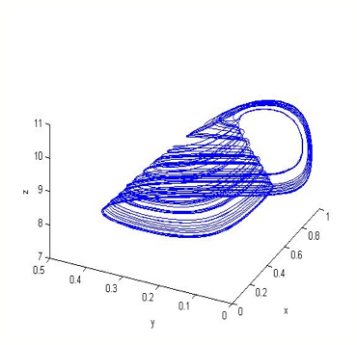
Figure 3: Above is the three-dimensional phase plot produced when b1=3.0. The result is a chaotic strange attractor.

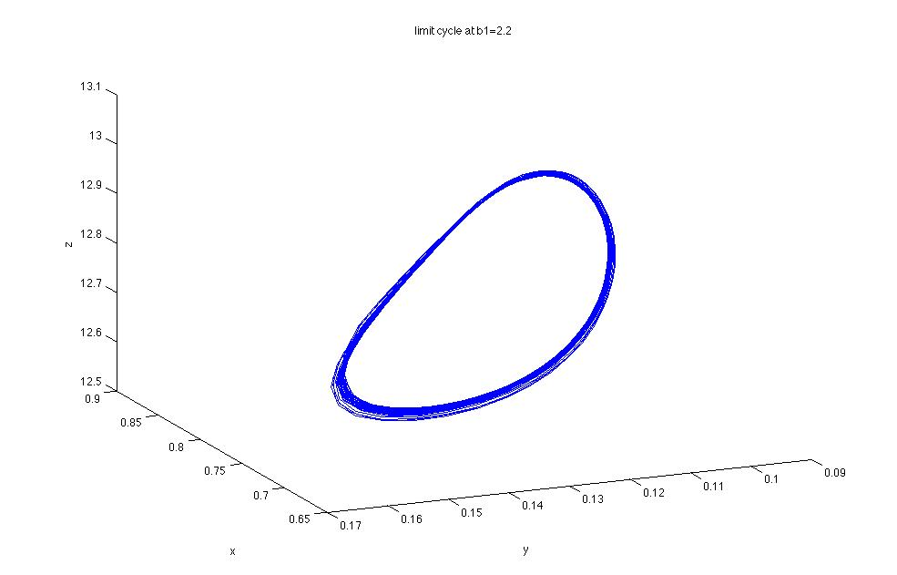
A
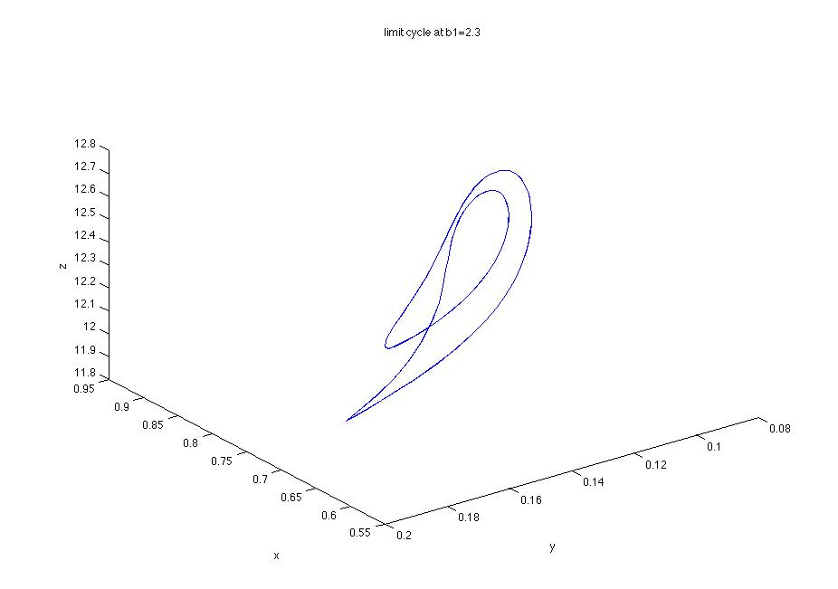
B
Figure 4 (A and B): The below are examples of three-dimensional phase plots exhibiting periodic behavior. A is the plot produced for b1=2.2 and B is the plot for b1=2.3. There are many other values which elicit periodic behaviors, these are simply two examples which can be produced merely by small changes in the value of b1 (i.e. predation rate per unit prey of species Y on X.)

We will focus on the parameters which produce a strange attractor in the three-dimensional phase plot and exhibit chaos. While the individual species versus time graphs for such parameters initially appear to be periodic for approximately every 150 time steps, upon closer investigation of 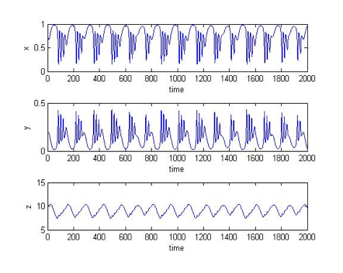Figure 5: The above graphs are individual species versus time graphs for the parameters outlined in Figure 2, where b1=3.0. The three-dimensional phase plot for the same parameters is seen in Figure 2.

the graphs seen in Figure 3, it is clear that there are variations in these time steps and the behavior is, in fact, not periodic. The three-dimensional phase plot in Figure 3 for these same parameters provides further evidence towards chaotic behavior and provides an interesting ecological story. Starting at an initial point at the bottom of the “teacup’s” “handle”, predator Z plummets in numbers here. Since species Y no longer experiences the effects of predation by species Z, large swings in the populations of X and Y occur at the bottom of the teacup. As species X grows in population there is a lag until species Y’s numbers increase as well and then a lag until the increase in Y leads to a decrease in X and so on. As Z increases in response to Y’s increases, regulating the population of Y and, indirectly, X, the swings in X and Y are gradually damped. Eventually, Z’s increase in numbers leads to a crash in species Y and, thus, an outbreak in X, bringing the system back to the “handle”. This process then repeats itself (Hastings and Powell, 1991).

Bifurcation Diagram Analysis

The first quantitative analysis that we did on the three-species unilateral ODE system was to create a bifurcation diagram. Bifurcation diagrams can be good indicators of dynamical behavior and can be used to visualize chaotic behavior and find parameters for which chaos can exist (Alligood, 1996). We set out to reproduce the bifurcation diagram results from the Hastings and Powell paper, in which a graph of local maxima of z -vs.- b1 was used to investigate dynamical behavior. We used the ode45 solver in Matlab to produce x, y, and z data for our ODE system. We solved the system each run up to a maximum time of 15000 and, in order to reduce the appearance of transient states before a chaotic attractor or periodic orbit appeared, we removed the first
7500 time steps. Since the graph for z was quite “noisy” for many values of b1, the data had to be smoothed in order to avoid spurious data points from being returned. We found that the most accurate method for doing this in Matlab was the “lowess” method, which is a weighted local regression using a 1st degree polynomial model. To avoid erroneous data, different spans for the weighted average calculations had to be used for various values of b1, which had to be determined experimentally. Approximating the first and second derivatives using the gradient function, we were able to find local maxima of the smoothed data. Using the t-values from these maxima we were able to find the local maxima of the z-data by finding local maxima in a small range about each t-value. These maxima were then calculated for 1001 different values of b1 in a range from 2.2 to 3.2 using randomized initial conditions and then graphed vs. b1.

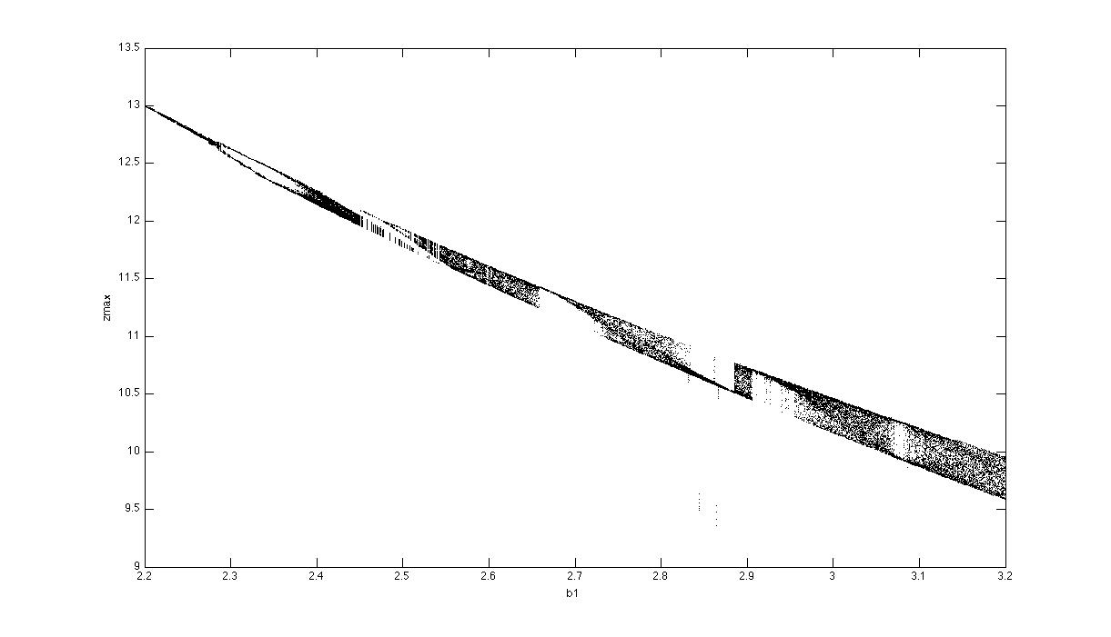

Figure 6: Bifurcation diagram for b1 values [2.2:3.2] in increments of .001. Diagram is the local maxima of the z-component of the orig. ODE system against b1 using the parameters specified in Figure 2. Method specified in text. Diagram shows values of b1 for which the ODE system displays limit cycle behavior (eg. b1=2.2) and for which the local maxima fill out a range, which can indicate chaos (eg. b1=3).
Our bifurcation diagram closely mimics the one produced by Hastings and Powell and allows us to draw many of the same conclusions. Our bifurcation diagram displayed many instances of period-doubling, which is one of the basic indicators of chaotic behavior, i.e. in the logistic map. At certain points of b1 (eg. b1=2.465), the system displays very interesting dynamical behavior in that both limit-cycles and chaotic orbits seem to occur which indicates that choice of initial condition can affect behavior. At many points (eg. b1=2.66 approx.) this diagram shows rapid changes between chaotic and periodic behavior as well. The implications of these results could be important for study of ecological systems because slight perturbations in initial conditions or system parameters can lead to completely different behavior, making precise study of ecological systems more difficult.

Poincaré Map Analysis

In order to further investigate the results from the bifurcation diagram, we reproduced Poincaré Maps that Hastings and Powell had produced in order to further investigate behavior at two b1 values they believed to be chaotic. They chose b1=3 and b1=6 and produced Poincaré section graphs and maps for these values. We reproduced these results using the ode solver ‘Events’ function for zero-crossings and collected data-points from downward crossings of planes set at z=9 for b1=3 and z=3.7 for b1=6 (this collected points from the “handle” portion of the chaotic attractor). We first plotted Poincaré section graphs of x vs. y for successive z-plane crossings, which resulted in x and y relations that were approximately linear for both b1 values. Because of this linear relationship between x and y, the behavior of the Poincaré Map can be approximated using one variable. 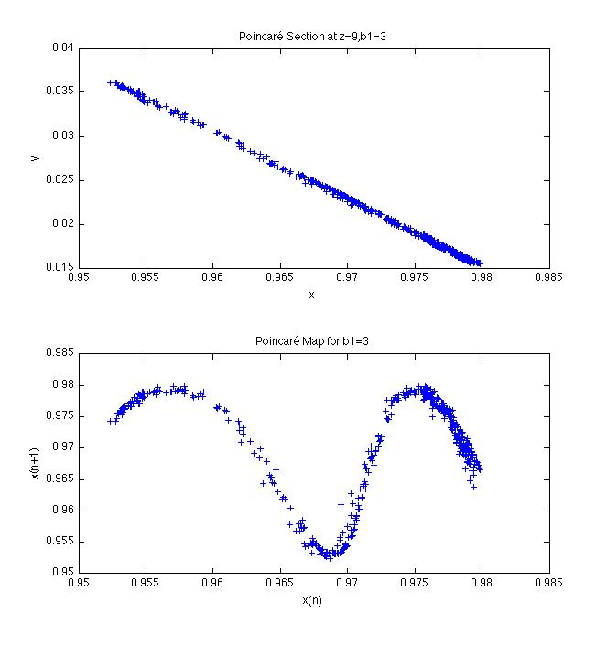A
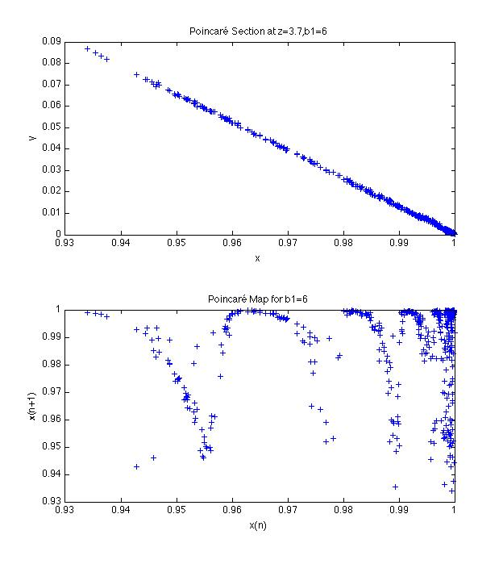B
Figure 7: Poincaré Section and Map for model system with parameters specified in Figure 2 created by plotting downward crossings of z=9 for initial parameters b1=3 and z=3.7 for b1=6. Section graphs show approximate linear relationship between x and y, allowing for expression as a map on 1 variable. Poincaré Maps created with time-delay embedding show close adherence to a sinusoidal shape, indicating that an accurate x (n) ->x (n+1) 1d map could be established.

We did this by using time-delay embedding upon x, creating a plot of x (n) vs. x (n+1) where x (n) is the nth crossing of the z-plane. For b1=3 it is very clear that x (n) has strong predictive power for x (n+1) as the time-delay graph adheres very closely to a sinusoidal shape. Thus a x(n)->x(n+1) 1d mapping could be created that could well approximate the behavior of the time delay plot. Hastings and Powell noted that for 1d maps a steep average slope can be indicative of chaos, which our Poincaré maps clearly show. Since the Lyapunov number can be defined by the average slopes along an orbit for a 1d map we tried to approximate this for the Poincaré map at b1=3 (Alligood, 1996).

Definition 3.1 (Alligood, et al., 107): Let f be a smooth map of the real line R. The Lyapunov number L(x1) of the orbit {x1, x2, x3,…} is defined as
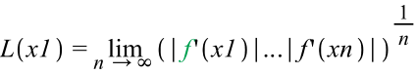

if the limit exists. The Lyapunov exponent h(x1) is defined as

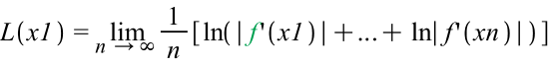

if this limit exists. Notice that h exists if and if L exists, and ln(L) = h.

Since the data for the time-delay map was noisy we used the “polyfit” function in matlab in order to find a degree-11 polynomial that closely approximated the data. From this polynomial we were able to use the “polyder” function to get an approximation for the derivative for our x(n) data. We calculated the average absolute value of the derivative for the data and then took the natural log to find approximate Lyapunov exponent h=1.03. This value is a rough approximate, but even allowing for a large margin of error in the calculation, this is still indicative of chaotic behavior in the Poincaré Map.
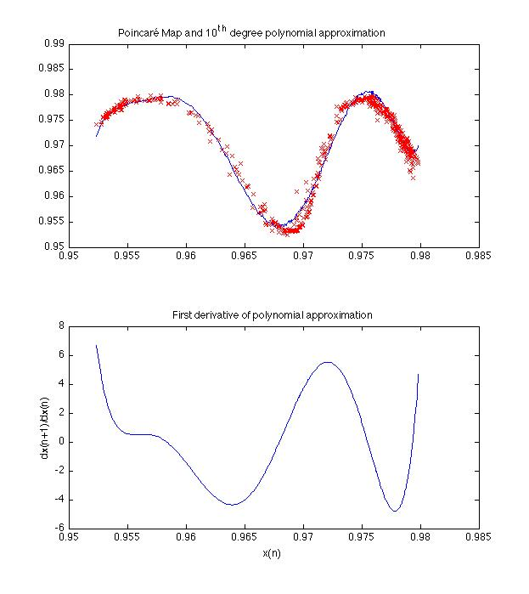
Figure 8: Shows Poincaré Map data plotted in red against the degree-10 polynomial approximation. Second image shows derivative graph of the polynomial approximation. This data was used to find the Lyapunov exponent h=1.03. Note: many different degrees were tried in polyfit, all of which either poorly approximated the data or gave roughly the same results for h.

Lyapunov Exponents of the Three-Tier Unilateral Trophic Cascade

To analyze the Lyapunov Exponents of the Three-Tier Unilateral model we used Matlab to analyze the system using two separate methods, both utilizing the ODE45 code provided by the system. The first involved the procedure created by Professor Alex Barnett. The Jacobean matrix of the system was found and then modified using the program entitled “three_tier_time1map.” The 12 components (3 components of the solution and 6 of the Jacobean matrix) were combined. The important step was dictating the interval size to numerically solve for t. Initially it was set to 1, but the value for h (the Lyapunov exponent) was not accurate. By decreasing the range and increasing the number of time steps, the Lyapunov exponents settled to a certain limit. The Jacobean was reshaped into a 3x3 matrix represented as DFx. In order to get accurate Lyapunov exponents in Matlab, the time1map was re-orthogonalized by averaging over multiple time steps and multiple loops. The final answer, with 10 loops and 500 measuring steps, was

h = (0.0186,-0.0407,-0.0755).

The single positive Lyapunov exponent implies the presence of chaos. However, it was important to check our systems to ensure that our math was correct and that the Lyapunov exponents calculated were also correct. We decided to test the model for sensitive dependence. By charting the resulting distance between the two flows over time we could estimate the Lyapunov exponent of the flow. Figure 9 shows the log(distance) between the flows over time. By estimating the slope of the linear increase represented in the chart, the Lyapunov exponent was estimated to be approximately 0.0184. This data confirms our first calculation of the Lyapunov exponent, and confirms the presence of chaos in this system given the specific parameters. An analysis of two trajectories also shows divergence over time, further confirming the presence of sensitive dependence in the system.
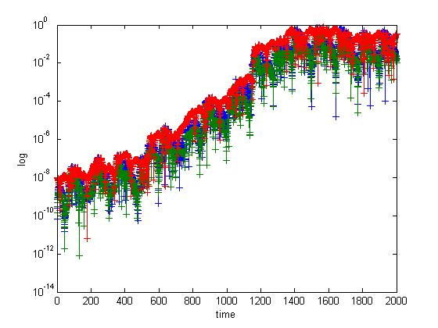
A
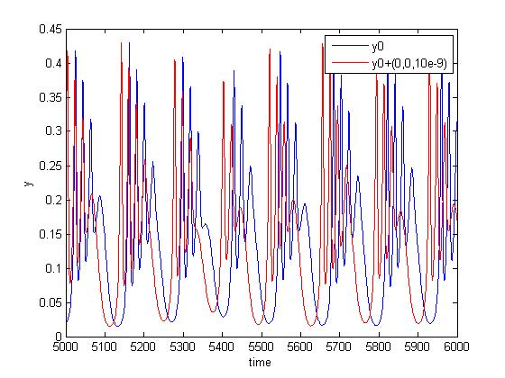
B
Figure 9: Chart A shows the log(distance) between the flows over time with the first having y0= (0.8,0.17,9.8) and the second having y1=y0+(0,0,1e-8). The positive slope represents a positive Lyapunov exponent. In estimating the Lyapunov exponent for the system we found the slope to be an average of estimates and equal to 0.0184. The positive Lyapunov exponent confirms sensitive dependence in the system denoting chaos. Chart B shows the separation of species y with two different, but very close initial conditions.

Cyclic Three-Tier Trophic Model Including Detritus Accumulation and Utilization

In addition to analyzing a three-species unilateral trophic cascade we analyzed a system in which the dead matter from the 2nd and 3rd level – from species Y and Z – accumulated and then added to the primary producer’s through a Holling’s type II function. Just as the handling time for higher order predators reaches a saturation point over a sufficiently long time interval, there is also a saturation point at which species X can no longer utilize the dead organic matter of species Y and Z. Therefore, the Holling’s type II function applies, and adds to the growth of the primary species pool. The entire system loses very little energy and there is an overall input of energy into the system through the primary producers. The following equations dictate the rate of change of each pool:

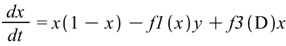
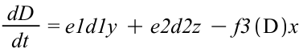

The detritus pool is dependent on the death of the higher order predators. However, only a proportion of the dead species accumulate in the pool because of outside affects on the system. Since the DOM (dead organic matter) only adds to the system, there is still an overall input of energy and biomass into the ecological community. The constants for the original parameters were kept the same. The new parameters are:
a3=.5;
b3=1.5;
e1=.75;
e2=.55;
Similar to the three tier trophic cascade, the cyclic model with a positive energy input (sunlight allowing for logistic growth of the primary producer) has a “tea-cup” shaped strange attractor (when species x, y and z are represented on the axes, it looks almost like a “clam shell” from above.) However, the large fluctuations in the x and y species occur more frequently than in the three tier model and the z species remains more stable, and never crashes below a certain point. The detritus pool increases linearly, since its growth is strictly dependent on the addition of dead matter, and the uptake of the 1st order primary producer (species X). Figure 10 shows the results of running the flows for 2000 time steps. The species appeared to be chaotic so we then analyzed the system for sensitive dependence.
By changing the initial conditions by only a miniscule amount and then recording the distance between the flows over time, we could estimate the value of the Lyapunov exponent. The slope of the log(distance)
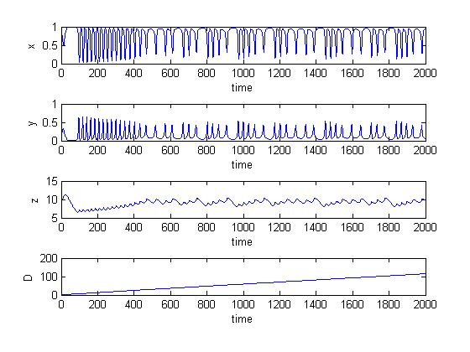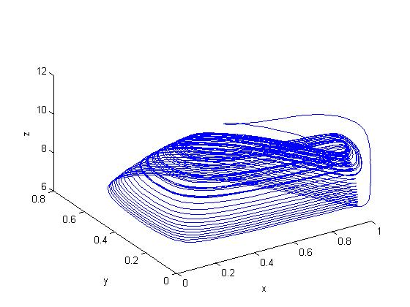
Figure 10: Part A shows the flows of all four species for 2000 time steps. The chart shows chaotic elements may be present in the system, since no clear periodic, stable orbit is present. B shows the flows depicted in a three dimensional model where the detritus pool is not shown. The shape of the 3D model is similar but distinct compared to the model of the unilateral three tier species system. The z species also does not collapse as low as it did in the three level trophic species, but species x and y both oscillate very quickly.

between the two flows is equivalent to the Lyapunov exponent. When evaluated we estimated the value to be h=0.0921. This positive Lyapunov exponent, in conjunction with the definitive positive slope of the chart in Figure 11 confirms the presence of sensitive dependence and thus chaos in the cyclic three tier model.
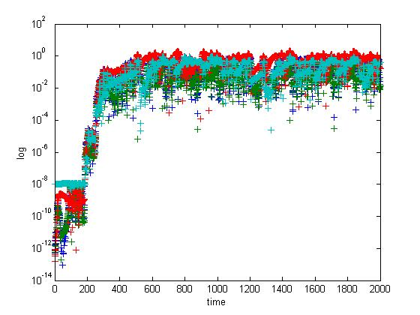
Figure 11: This chart shows the log(distance) between two flows when flow 1 has initial conditions of y0=(0.8, 0.17, 9.8, 1.0) and flow 2 has initial conditions of y0+(0,0,0,1e-8). The initial slope of the plot is clearly positive, indicating a positive Lyapunov exponent estimated to be 0.0921. The positive Lyapunov exponent indicates sensitive dependence in additional to chaos.

We also tested a closed cyclic three-tier model where there was no logistic growth in species X. The x(1-x) term was removed from the system so that the only growth was dependent on the DOM present in the system. The equation regarding the rate of change of species X was represented as
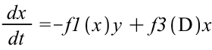.
All other equations were identical to the cyclic three tier model shown above. This model does not show any chaotic elements in its trajectories, since it was a closed system with no new input of energy or matter. Eventually, the higher level species die out and the lower level species reduce in biomass. Figure 12 shows the results of the four pools growth vs. time. These results do not show logistic growth at the lowest trophic level. With these parameters the close system falls into a stable, non chaotic orbit.
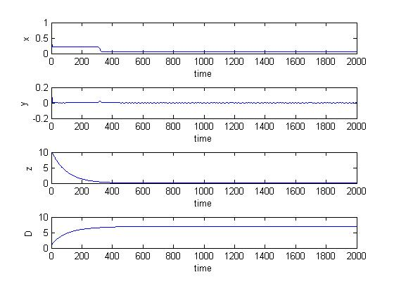
Figure 12: The chart shows a flow of a closed cyclic three-tier system. Each pool falls into a stable equilibrium at these parameters.

Four Tier Unilateral Trophic Cascade

We also analyzed a four tier unilateral trophic cascade, which added another predation level above the secondary consumer. We wanted to again test whether the system would have chaotic tendencies. The 4th level predator followed the same rules as the 2nd and 3rd level predators. Their population was based on predation on the 3rd level species. The equations analyzed were:

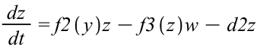
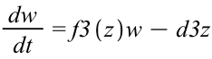

.

The parameters for the four tier model are consistent with the constants of the three tier model. The values of a3, b3 and d3 were 0.05, 4, and .009 respectively for our analysis. The y0 was equal to [0.8,0.17,9.8,1]. The graph of each species over time demonstrates similar results to the three species model, along with a collapse in the 4th trophic level species after a significant number of time steps. While the top predator is still present, the lower populations begin in a “tea cup” shaped strange attractor similar to the one seen in the three tier trophic cascade. However, over time they fall out of the tea cup and z approaches zero. When species Z gets to zero, there is a collapse in species W (zz as shown in Figure 13). Figure 13 shows both the four individual paths that each species exhibits over time and a three-dimensional flow of the lower three trophic level species. The flows in one and three dimensions seem to exhibit chaotic flow, since no clear presence of stable orbits could be observed.
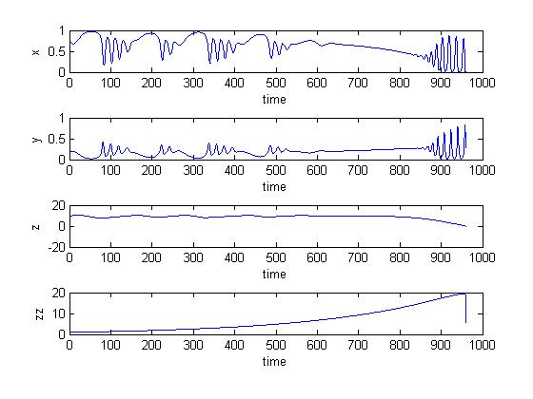
A
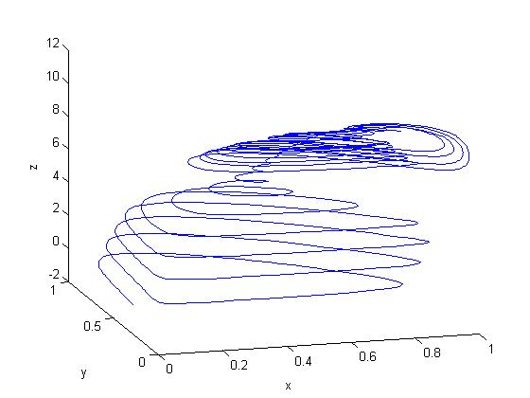
B
Figure 13: Part A shows the flows of all four species for 2000 time steps. The chart shows chaotic elements may be present in the system, since no clear periodic, stable orbit is present. B shows the flows depicted in a three dimensional model where the 4th level trophic species is not shown. The shape of the 3D model is similar but distinct compared to the model of the unilateral three tier species system. Even with the presence of the 4th level predator the three lower species seem to fall into the same “tea-cup” strange attractor as they did in the three species system. However, after a time the flow falls out of the attractor as species z falls to zero. This chart was only mapped for 925 time steps because after that the highest trophic level collapses to zero.

Due to partially inconclusive results through the phase plots alone, we analyzed the Lyapunov exponents for the flows in two dimensions. Again, using a sensitive dependence model we graphed the log(distance) between the two flows when their initial conditions were changed by 1e-8 in the 4th trophic level condition. When analyzed using Matlab we estimated the Lyapunov exponent to be positive; h=0.0224. 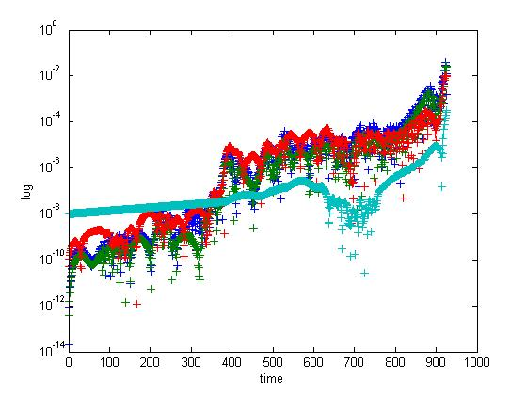
Figure 14: This chart shows the log(distance) between two flows when flow 1 has initial conditions of y0=(0.8, 0.17, 9.8, 1.0) and flow 2 has initial conditions of y0+(0,0,0,1e-8). The initial slope of the plot is clearly positive, indicating a positive Lyapunov exponent estimated to be 0.0224. The positive Lyapunov exponent indicates sensitive dependence in additional to chaos. This chart was only mapped for 925 time steps because after that the highest trophic level collapses to zero.

Conclusions

The first part of our analysis looked to reproduce the work of Hastings and Powell by analyzing a simple three trophic level system and proving that chaos can exist in a simple biological system in nature. The type “II” functions utilized in the equations have been used accurately for over fifty years (Hasting and Powell, 1991). These saturation functions are elements which lead to chaos in these dynamical systems. As the parameters become closer to actual biological data, the system becomes chaotic (Hastings and Powell, 1991). The first model suggests that chaos may exist in nature far more than was originally thought and that it is possible for chaos to exist in multi-trophic food chains in various ecosystems.
In a two tier system, the predator and prey populations often exhibit undulations in time delayed reactions. When analyzing the three tier system, chaos ensued when the oscillations between X and Y, Y and Z were not “harmonic” (Hastings and Powell, 1991). Hastings and Powell believed that, unless the two oscillations were in perfect sync, sensitive dependence and chaos could be observed in the system. In a simple two species model, with only one predator and one prey, the populations are allowed to oscillate over time, usually having a stable two period orbit or approaching a single equilibrium (McCann, Kevin and Peter Yodzis, 1994).
In nature, there are rarely three tier unilateral trophic cascades. Most food webs of a given community are infinitely more complicated. Hastings and Powell conjectured that in higher level food chains you would again find chaotic behavior, but, since more pools and more constants were involved, it would be infinitely harder to analyze. The cyclic three tier model applies to many marine and terrestrial ecosystems in nature. Marine systems especially rely on the supply of dead organic matter to provide the primary producers with nutrients to grow and reproduce. Since on the open ocean, there is little influx of terrestrial nutrients, DOM is the only real input of nutrients for many species living in the water column, unexposed to sunlight. The DOM of a system usually adds to the carbon influx at the lower levels. This happens in terrestrial systems and aquatic systems through decomposition. All primary producers require both sunlight and an influx of nutrients in order to grow and proliferate. This model shows that with a net increase in nutrients, and adequate energy to grow, the system can present chaotic dynamics. This again supports Hastings and Powell’s hypothesis that chaos will exist often in natural systems. It also shows how a system with positive energy input will have an excess of nutrients. It can be hypothesized that there is an outflow of nutrients from these net positive systems into the closed cyclic systems, where there is no influx of outside energy.
The same conclusion was supported in our four tier unilateral cascade analysis. By analyzing the system where it was defined, the multiple oscillations between predator-prey interactions created chaotic orbits for the parameters of the system. As expected, by adding another oscillating relationship (Z and W [also shown as ZZ]), the chance of having exact multiples of oscillation frequency became less likely.
Also, the time scale of the analysis must be considered. In every system over a short time period, the model can do an accurate prediction for two separate initial points. It is not until you start looking far into the systems’ future that chaotic elements emerge. For ecologists, this presents a problem for long term analysis of certain ecosystems. It may be impossible to tell exactly how a species will react to a change in climate or available space over a five to ten year period. The repercussions of small changes could have significant affects on the ecosystem over long periods of time. These models also do not take into account every variable present in a natural food web. It is therefore possible that chaotic systems do not occur in most natural chains. However, given that we were able show sensitive dependence in variable simple systems, it implies that more complex systems would show even greater layers of uncertainty.
In the future, continuing to analyze systems for the short term will prove to be a vital skill. The change in climate is making consistently small perturbations in complex biological equations, thereby changing the long-term effects of many species. It is likely that if we do not stop these small changes in our food webs the composition of multiple complex food webs will be changed in the coming years and well into the future.

Acknowledgements

We would like to thank Professor Alex Barnett for providing guidance for our project. He helped us in creating our Matlab codes and provided models of his own Matlab code for us to work with. Without his help this work would not have been possible. All methods were carried out using MATLAB 7.8.0 (R2009a) and all equations were formatted using Maple 11.0 (2007). All Matlab code is shown in the Appendices.

Literature Cited
Gamarra, Javier and Ricard Sole. 2000. Bifurcations and chaos in ecology: lynx returns revisited. Ecology Letters 3:1-8.
Hastings, Alan and Thomas Powell. 1991. Chaos in a Three Species Food Chain. Ecology 72:896-903
K.T. Alligood, T. D. Sauer, J. A. Yorke. Chaos: An Introduction to Dynamical Systems. (Springer-Verlag, New York, 1996)
McCann, Kevin and Peter Yodzis. 1994. Biological Conditions for Chaos in a Three-Species Food Chain. Ecology 75:561-564.
Skalski, Garrick and James Gilliam. 2001. Functional Responses with Predator Interference: Viable Alternatives to the Holling’s Type II Model

