Introduction
The study of the n-body problem—the problem of determining the motion of n massive particles interacting through gravitational attraction—is essentially as old as the idea of gravity. Beginning with the publication of the Principia Mathematica in 1687, its students include many of the great mathematical thinkers of the 17th, 18th, and 19th centuries: Newton, Bernoulli, Euler, Lagrange, Poincaré, and Jacobi, to name a few.
Because most celestial bodies can be approximated as point particles, the n-body problem is also essentially the foundation of celestial astronomy. Twenty-three years after Newton formalized his theory of gravity, Johann Bernoulli proved that for the n = 2 case the orbits of the two bodies always describe a conic section.
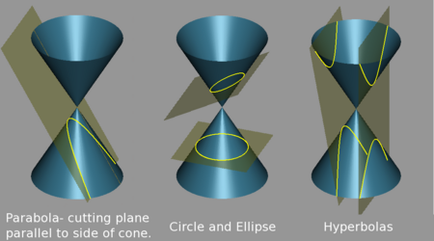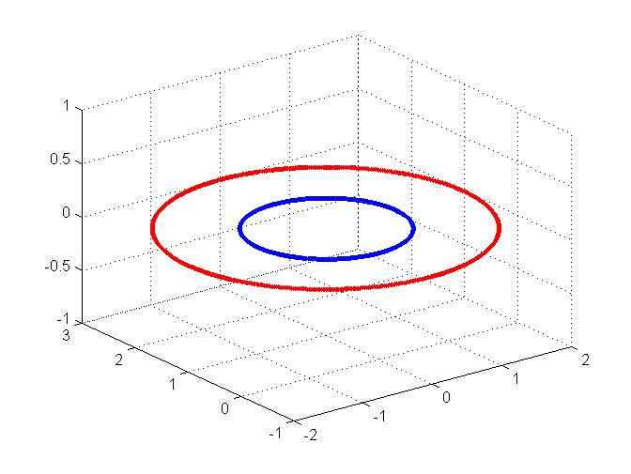
For cases where n > 2, however, the motion of the bodies becomes incredibly complex and the system exhibits chaotic properties. In fact, Poincaré’s work on the three-body problem in the late 19th century led him to the discovery of stable and unstable manifolds, homoclinic points, and the beginnings of chaos theory and the theory of dynamical systems. For an overview of the n-body problem’s history, see the appended timeline.
State Space and Equations of Motion
The exact state of any body can be expressed in two vectors—a position vector describing the location of the particle and a momentum vector describing its velocity and mass. Each of these vectors has three spatial dimensions, which yields a state space of 6n. For the 3-body problem, the special case where n = 3, the state space is 18-dimensional and is expressed in a single vector:
Equating Newton’s expression for gravity with his second law, F = ma, we can describe the motion of the 3 bodies. Let P_{i} represent particles with masses m_{i} for i = 1,2,3. Define r_{ij} to be the distance between P_{i} and P_{j}. Also define q_{i} to be the j^{th} component of the position vector for the i^{th} body. Then the equations of motion where G is the gravitational constant are:
Applying Poincaré Maps and Hamiltonian Analysis to the 3-Body Problem
Euler proposed a set of simplifications to the 3-body problem which later came to be known as the restricted 3-body problem. In this subset of the n = 3 case it is assumed that one of the bodies, known as the planetoid, is so much less massive than the other two objects that its gravitational force on them is negligible. The orbits of the two massive objects, then, describe a conic section, and the problem is reduced to determining the movement of the planetoid. Also assuming that the z-component of the planetoid's initial velocity is zero, we are left with only four unknown variables: the position and momentum of the planetoid in the x and y dimensions. In this way, the original 18-dimensional state space of the 3-body problem is reduced to a system of two second order differential equations, which can be further simplified to four coupled first order equations.
At this juncture in his analysis, Poincaré realized that if he imposed a rotating coordinate system and set y = 0, the Hamiltonian for the restricted 3-body problem would simplify to a palatable
where C is a constant of the system. Using this knowledge, he began to examine the states of the system as it pierced the surface of section y = 0. Recording the x-positions and momentum in the x-dimension every time the planetoid intersected the plane y = 0 and the momentum in the y-dimension was greater than zero, he developed a map which transformed the continuous dynamical system into a discrete one. He soon realized that his new map, (later known as a Poincaré map) preserved many properties of the continuous system's periodic and quasiperiodic orbits, despite the fact that its state space was one dimension smaller than the original system's.
Libration Points
Lagrange first discovered the Libration or Lagrangian points in 1772, during his studies of the restricted 3-body problem. They are the five locations in space for which the force imparted by the two massive bodies will provide the planetoid with “precisely the centripetal force required to rotate with them.” Because of the triangular configuration of the bodies at L4 and L5, the above conclusion holds even if the third object has a non-negligible mass. For this reason we often used the L4 initial conditions for our simulations.
The figure to the left is a contour plot of the gravitational potential felt by the planetoid. The red and blue arrows indicate the slop of the contour plot, red meaning an upward slope and blue meaning downward. L4 and L5, then, are maximums, and L1, L2, and L3 are saddle points.

Image courtesy of http://map.gsfc.nasa.gov/m_mm/ob_techorbit1.html
Simulations
We used MATLAB to create an environment to simulate the 3-body problem for various initial conditions. In order to view these trajectories, our first task was to break down the 9 second order differential equations into 18 coupled first order equations. We then used MATLAB’s ode45 function to evaluate them at different time intervals.
The second challenge was determining the initial conditions that would yield the few known orbits of the 3-body problem. We were able to accomplish this through a reading of published research, intuition, and trial and error.

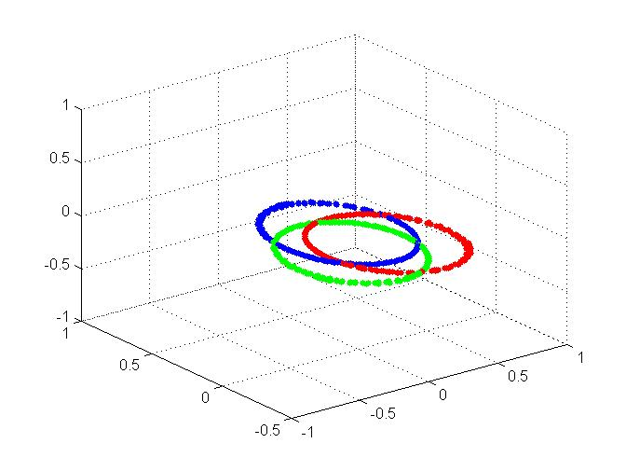
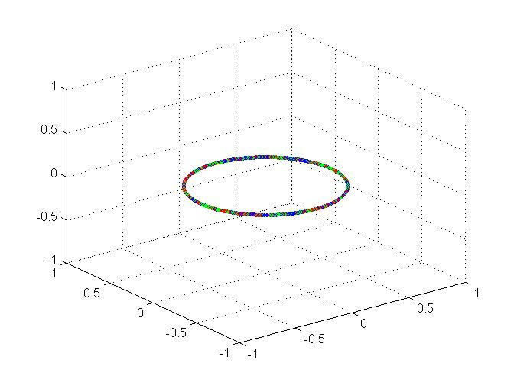

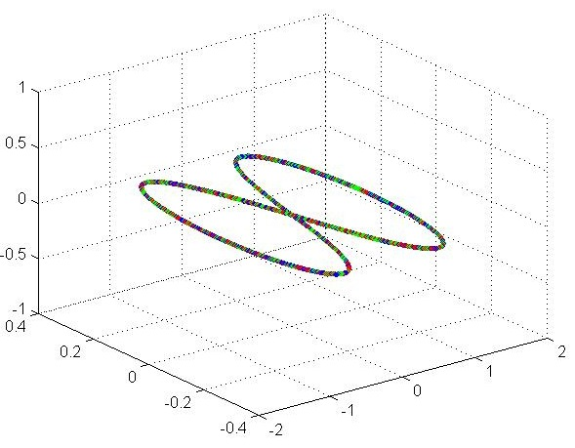
The above orbits are two known solutions of the Libration points L4 and L5. In both orbits all three particles have equal masses. For both orbits the magnitudes of the velocities of all three particles are equal. In the orbit to the left, the three particles always describe an equilateral triangle. While the orbits trace out their ellipses, the triangle grows and shrinks periodically. In the orbit to the right, the trajectory of the three particles traces out a circle while remaining at the vertices of an unchanging equilateral triangle.
The orbit to the right is known as the figure eight configuration. Christopher Moore first discovered this orbit in 1993, and Alain Chenciner and Richard Montgomery proved its existence in 2000. The figure eight is a stable periodic solution of three particles with equal masses.

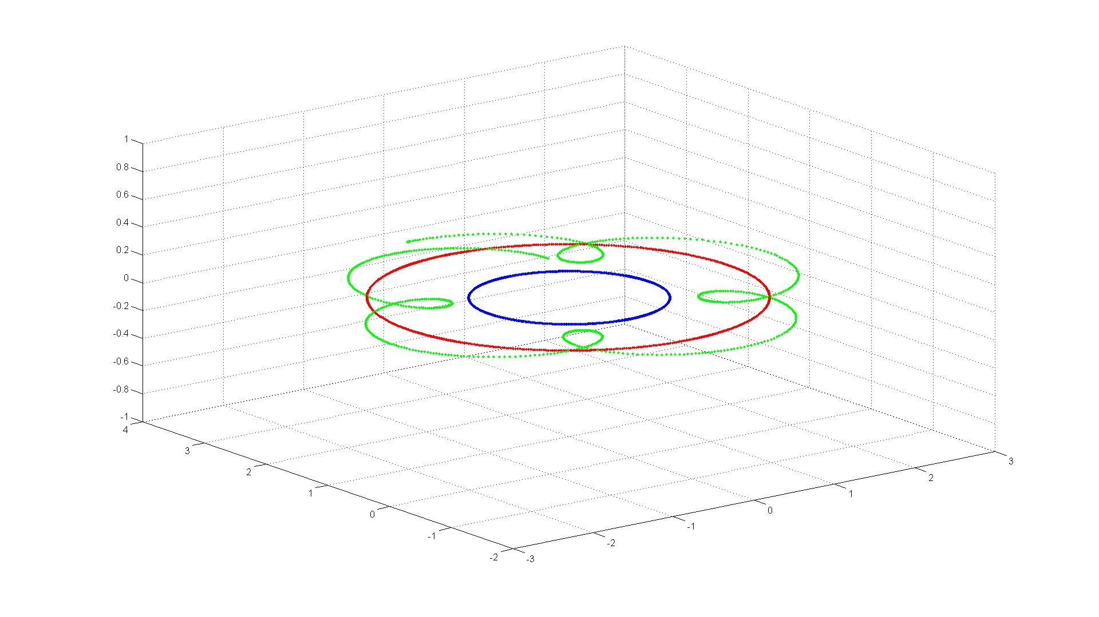
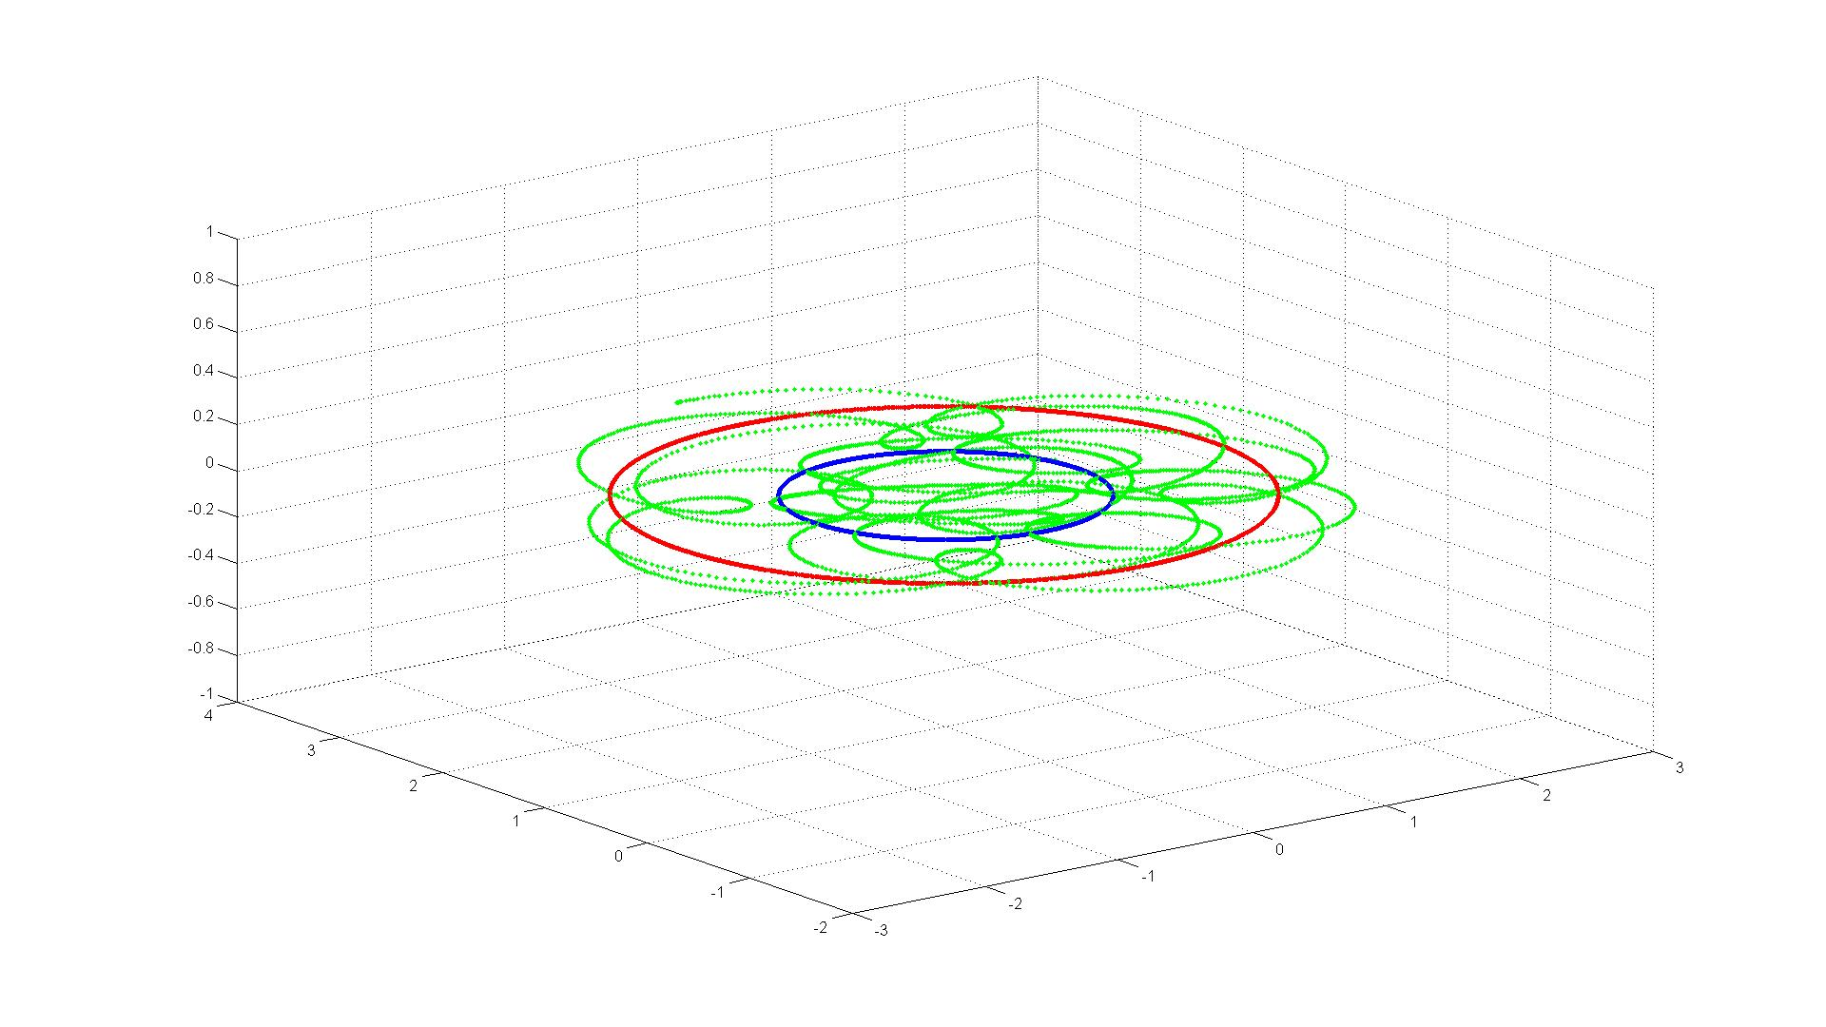

The above two orbits represent the evolution of a solution of the restricted 3-body problem. Snapshots are taken at t = 27 and t = 100. Note that the massive bodies rotate neatly about their barycenter (their paths are shown in red and blue), while the planetoid (in green) moves a-periodically through the system.
Lyapunov Exponents
We evaluated Lyapunov Exponents in two distinct ways. First, we calculated them directly by updating the Jacobian matrix of the 18-dimensional flow. (This required us to create a time-1 map for our three body code, and adapt the Lyapflow program posted by Professor Barnett. See appendix for source code.) Second, we measured them indirectly by launching two particles with almost identical initial conditions and determining the slope of the log of the distance between the two bodies.
Since Chenciner and Montgomery had shown the figure eight configuration to be stable, we first ran our Lyapunov Exponent code with the initial conditions of the figure eight. We found that our direct method of calculation produced Lyapunov Exponents which tended to zero as the total number of time steps was increased. Below is a chart which tracks the changes of four Lyapunov Exponents over time. A full table of the data is provided in the appendix.

Our second method, which tracks the rate at which two near-identical particles diverge, yields the chart below. A cursory glance shows distance does not increase exponentially with time (the relation is linear). This implies that the figure eight configuration’s largest Lyapunov Exponent is zero—a finding that is consistent with the literature’s claim of stability.
We then applied the same two methods to the restricted 3-body problem. Our direct method produced the chart below. Note that like the figure eight configuration, many of the Lyapunov Exponents approach zero as time increases. The largest exponent, however, changes at a linear rate and approaches a value of approximately .05.
Our second method applied to the planetoid of the restricted 3-body problem resulted in a distance between the two trajectories that is both sensitively dependent on initial conditions as well as chaotic.

Changing the y-axis to a logarithmic scale and examining the portion of the chart when the distances are still diverging, we approximate the growth rate with the red line in the chart below. The slope of this line, .05, is an approximation for the largest lyapunov exponent of the restricted 3-body problem. This agrees with our findings from the first method.

Conclusion
The n-body problem possesses a richness and subtlety often sought after in the study of mathematics. E. T. Whitaker once called it “the most celebrated of all dynamical problems.” Our research gave us a background knowledge of its history and allowed us to explore specific cases in more detail. We succeeded in creating an engine in MATLAB to simulate trajectories for the n = 3 case, and also analyzed the stability of these orbits using two methods of Lyapunov Exponent calculation. The most striking impression from our studies is the overwhelming depth and complexity inherent to the problem. Referring to his troubles with the n > 2 case, Newton is rumored to have once remarked, “his head never ached but with his studies of the moon.”

Works Cited
Barrow-Green, June. Poincaré and the Three Body Problem. Vol. 11. United States of America: American Mathematical Society, London Mathematical Society, 1997.
Chenciner, Alain, and Richard Montgomery. "A Remarkable Periodic Solution of the Three-Body Problem in the Case of Equal Masses." The Annals of Mathematics 2nd ser. 152.3 (2000): 881-901. JSTOR. Dartmouth College Library, Hanover. 12 Nov. 2007 <http://faculty.ifmo.ru/butikov/projects/collection3.html>.
"Conic Section." Answers.Com. 2007. 4 Dec. 2007 <http://www.answers.com/topic/conic-section?cat=technology>.
Danby, J. M. A. "Stability of the Triangular Points in the Elliptic Restricted Problem of Three Bodies." The Astronomical Journal 69 (1964): 165-172. 12 Nov. 2007 <http://articles.adsabs.harvard.edu/cgi-bin/nph-iarticle_query?db_key=AST&bibcode=1964AJ.....69..165D&letter=.&classic=YES&defaultprint=YES&whole_paper>.
Danby, J. M. A. "The Stability of the Triangular Lagrangian Point in the General Problem of Three Bodies." The Astronomical Journal 69 (1964): 294-296. 12 Nov. 2007 <http://articles.adsabs.harvard.edu/cgi-bin/nph-iarticle_query?db_key=AST&bibcode=1964AJ.....69..294D&letter=.&classic=YES&defaultprint=YES&whole_paper=YES&page=294&epage=294&send=Send+PDF&filetype=.pdf>.
Hinshaw, Gary. "WMAP Observatory_Lagrang_Points." Wilkinson Microwave Anisotropy Probe. 6 Feb. 2006. NASA. 5 Dec. 2007 <http://map.gsfc.nasa.gov/m_mm/ob_techorbit1.html>.
Hobbs, David. "Lund Observatory: David Hobbs." Lund Observatory: Space Astronomy. 1 June 2007. Lund University. 5 Dec. 2007 <http://www.astro.lu.se/~david/Gaia1.html>.
"Lagrangian Point." Wikipedia, the Free Encyclopedia. 28 Nov. 2007. Wikipedia.Org. 28 Nov. 2007 <http://en.wikipedia.org/wiki/Lagrange_points>.
"N-Body Problem." Wikipedia, the Free Encyclopedia. 27 Nov. 2007. Wikipedia.Org. 19 Nov. 2007 <http://en.wikipedia.org/wiki/N-body_problem>.
Ross, Shane. "Shane Ross: Movies / Animations." Shane Ross | Dynamics, Control, and Computation. 2007. Virginia Tech. 1 Dec. 2007 <http://www.cds.caltech.edu/~shane/movies/>.
Woods, David, and Frank O'Brien. "Apollo Flight Journal." The Apollo 15 Flight Journal. 30 Dec. 2004. NASA History Division. 28 Nov. 2007 <http://history.nasa.gov/ap15fj/14solo_ops2.htm>.

Most of the significant bodies in our solar system are spherical, and the distances between them are relatively great.
The left figure shows the four possible conic sections. http://www.answers.com/topic/conic-section?cat=technology. The right figure is a trajectory of two bodies simulated in MATLAB.
Hobbs, David. "Lund Observatory: David Hobbs." Lund Observatory: Space Astronomy. 1 June 2007. Lund University. 5 Dec. 2007 <http://www.astro.lu.se/~david/Gaia1.html>.
Chenciner, Alain, and Richard Montgomery. "A Remarkable Periodic Solution of the Three-Body Problem in the Case of Equal Masses." The Annals of Mathematics 2nd ser. 152.3 (2000): 881-901. JSTOR. Dartmouth College Library, Hanover. 12 Nov. 2007 <http://faculty.ifmo.ru/butikov/projects/collection3.html>. p. 882
Barrow-Green, June. Poincaré and the Three Body Problem. Vol. 11. United States of America: American Mathematical Society, London Mathematical Society, 1997, p. 7
Barrow-Green, June, p. 7

